**Lab 4**

**List the available shells in your system.**

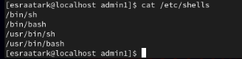

**List the environment variables in your current shell.**

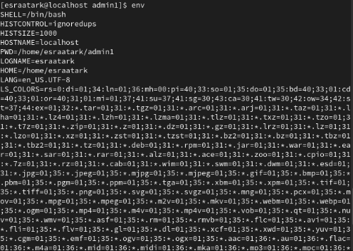

**List all of the environment variables for the bash shell.**

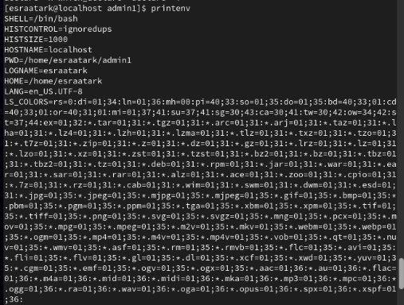

**What are the commands that list the value of a specific variable?**

**echo $VARIABLE_NAME**: Commonly used to display a specific variable's value.

**printenv VARIABLE_NAME**: Directly shows the value of a specific environment variable.

**env | grep VARIABLE_NAME**: Lists a specific environment variable using grep.

**set | grep VARIABLE_NAME**: Lists shell variables and functions, filtered with grep.

**Display your current shell name.**



**State the initialization files of: sh, ksh, bash.**

**sh:**

**Login:** /etc/profile, ~/.profile

**ksh:**

**Login**: /etc/profile, ~/.profile

**Non-login**: ~/.kshrc

**bash:**

**Login:** /etc/profile, ~/.bash_profile (or ~/.profile)

**Non-login:** ~/.bashrc

**Logout:** ~/.bash_logout

**Edit in your profile to display date at login and change your prompt permanently.**

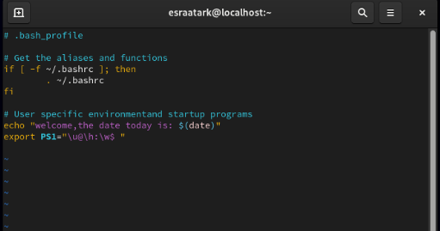

**10.Execute the following command :**

**echo \ then press enter**



**What is the purpose of \ ?**

The backslash (\) is used as an escape character. It tells the shell to escape the next character. However, in this case, the backslash is not followed by a character, so it causes the shell to expect more input from you. The echo command does not output anything, and the prompt changes to >.

**Notice the prompt ”>” what is that? and how can you change it from “>” to “:”.**

the > prompt is displayed when the shell expects more input to complete a command. It appears when you have entered a command that the shell cannot execute because it's incomplete. In this case, the shell is expecting you to finish the command (i.e., provide the rest of the string after the backslash). The shell remains in this state until you complete the command or cancel it

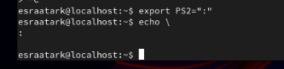

**Create a Bash shell alias named ls for the “ls –l” command**

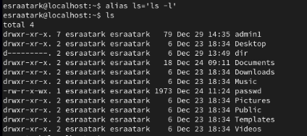

**Issue the command sleep 100:**



This will make the terminal wait (sleep) for 100 seconds.

**Stop the last command.**



**Resume the last command in the background**



**Issue the jobs command and see its output.**



**Send the sleep command to the foreground and send it again to the background.**

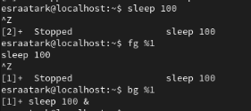

**Kill the sleep command.**

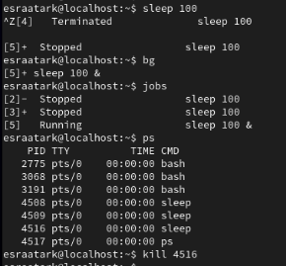

**Display your processes only**

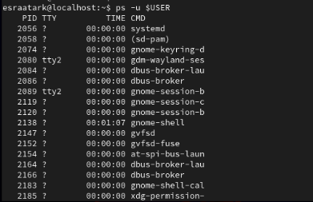

**Display all processes except yours**

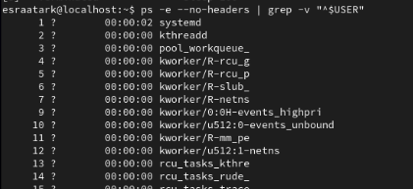

**Use the pgrep command to list your processes only**

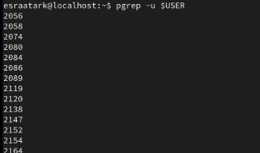

This will display the process IDs of all processes owned by your user.

**Kill your processes only.**



